

DELTA FARMS WATER CONTROL DISTRICT

INDIAN RIVER COUNTY

Regular Board Meeting August 18, 2026
8:15 A.M.

Special District Services, Inc.
The Oaks Center 2501A Burns Road
Palm Beach Gardens, FL 33410
www.deltafarmswcd.org 561.630.4922 Telephone 877.SDS.4922 Toll Free 561.630.4923 Facsimile

AGENDA DELTA FARMS
WATER CONTROL DISTRICT
Offices of Carter Associates 1708 21st Street
Vero Beach, Florida 32960

REGULAR BOARD MEETING
August 18, 2026
8:15 A.M.

- Call to Order
- Proof of Publication… Page 1
- Establish Quorum
- Additions or Deletions to Agenda
- Comments from the Public
- Approval of Minutes
  - June 16, 2026 Regular Board Meeting Minutes… Page 2
- Reports
  - Treasurer’s Report… Page 6
  - Engineer
    - Status Report
  - Attorney
  - Chairman
- Old Business
- New Business
  - Discussion of Board Workshop
- Administrative Matters
- Board Member Comments
- Adjourn

AFFIDAVIT OF PUBLICATION

LocaliQ
Florida
GANNETT

PO Box 631244 Cincinnati, OH 45263-1244

DELTA FARMS WATER CONTROL DISTRICT

Laura Archer Delta Farms WCD 2501 Burns RD # A
Palm Beach Gardens FL 33410-5207

STATE OF WISCONSIN, COUNTY OF BROWN

Before the undersigned authority personally appeared, who on oath says that he or she is the Legal Advertising Representative of the Indian River Press Journal/St Lucie News Tribune/Stuart News, newspapers published in Indian River/St Lucie/Martin Counties, Florida; that the attached copy of advertisement, being a Legal Ad in the matter of Govt Public Notices, was published on the publicly accessible websites of Indian River/St Lucie/Martin Counties, Florida, or in a newspaper by print in the issues of, on:

SCN StLucie-lndianRv-Stuart 10/10/2025 SCN tcpalm.com 10/10/2025

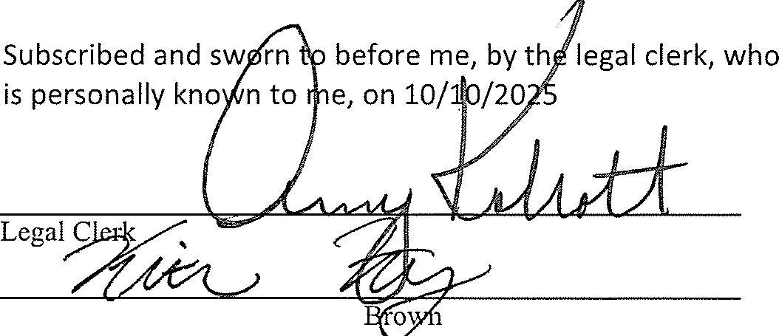
Affiant further says that the website or newspaper complies with all legal requirements for publication in chapter 50, Florida Statutes.

Notmy, State of WI, County of
:J·l·(/7
My commission expires
FISCAL YEAR 202S/2026 REGULAR MEETING SCHEDULE
NOTICE IS HEREBY GIVEN that the
Board of Supervisors (the ueoard�) of the Delta Farms Water Cont10! District {the "District") will hold Regular Board Meetings (the UMeeting,. or *Meetings�) at the offices of Carter Associates located at 1708 21st Street, Vero Beach, Florida 32960 at 8:15 a.m. (*•unless otherwise noted0) on the follow• ing dates:
October 21, 2025
November 18, 2025
0oocember 16,2025..,.
J�nuary 20, 2026
February 17, 2026
March 17 2026
April 21, 2026
May 19, 2026
June 16, 2026
July 21, 2026
August 18, 2026
September 22, 2026
nThe December 16, 2025, Annual Landowners' Meeting will be he!d at the offices of Collins Brown Barkett, Chartered, located at 756 Beachland Boulevard, Vero Beach, Florida 32963 ,'!It 9:00 a.m. The Regular Board Meeting will immedi-ately follow the Annual Landown• ers' Meeting at the same loca-tion.��
The purpose of the meetings is to conduct any business coming before the Board. Meetings are open to the public and will be conducted in accordance with the provisions of Florida law. Copies of the Agendas for any of the meet• ings may be obtained from the District's website
www dottafarmswcd org or by contacting the District Manager at 772-345-5119 or by email at
b.t.a.k..!.l.m.@�g and/or toll free at 1-877-737-4922 prior to the date of the particular meeting. The Meetings are open to the public and will be conducted in accor-dance with the provisions of Florida law for special districts. The Meet-ings may be continued to a date, time and place to be specified on the record at the Meeting.
From time to time a Supervisor may
participate by telephone; there-fore. a speaker telephone may be present at the meeting location so that Supervisor may be fully informed of the discussions taking place, Said meeting{s) may be continued as found necessary to a time and place specified on the record.
If any person decides to appeal any decision made with respect to any matter considered at these meet-ings, such person will need a record of the proceedings and such person may need to ensure that a verbatim record of the proceedings is made at his or her own expense and which record includes the testi-mony and evidence on which the appeal is based.
In accordance with the provisions
of the Americans with Disabilities Act, any person requiring special accommodations or an interpreter to participate at any of these meet-ings should contact the District Manager at 772-345·5119 and/or toll free at 1•877-737-4922 at least seven (7) days prior to the date of the particular meeting.
Meetings may be cancelled from time to time without advertised notice.
DELTA FARMS WATER CONTROL DISTRICT
www dcltnfncmsWcd orn
PUBLISH; INDIAN RIVER PRESS
JOURNAL 10/10/25 #11732337

PO#:
# of Copies:
1
Publication Cost: | $194.08
Tax Amount: | $0.00
Payment Cost: | $194.08
Order No: | 11732337
Customer No: | 1126751

DFW 2025-2026 mtg sc

THIS IS NOT AN INVOICE!
Please do not use this form jiJr payment remillance.

Page 1 of 1
KAITLYN F
Notary Public State of Wisconsin

DELTA FARMS WATER CONTROL DISTRICT REGULAR BOARD MEETING & PUBLIC HEARING JUNE 16, 2026

- CALL TO ORDER

The Regular Board Meeting of June 16, 2026, of the Delta Farms Water Control District (the “District”) was called to order at 8:43 a.m. in the offices of Carter Associates located at 1708 21st Street, Vero Beach, Florida 32960.

PROOF OF PUBLICATION

Proof of publication was presented that showed notice of the Regular Board Meeting had been published in the Indian River Press Journal on May 27, 2026, and June 3, 2026, as legally required.

ESTABLISH A QUORUM

Mr. Sakuma stated that the attendance of Supervisors Rusty Banack and Tim Dooley constituted a quorum, and it was in order for the meeting to proceed.

Also in attendance were District Managers Frank Sakuma and Stephanie Brown of Special District Services, Inc.; and District Engineer Tyler Spencer of Carter Associates.

ADDITIONS OR DELETIONS TO AGENDA

There were no additions or deletions to the agenda.

COMMENTS FROM THE PUBLIC

There were no comments from the public.

APPROVAL OF MINUTES

March 17, 2026, Regular Board Meeting and April 21, 2026, Special Workshop
The March 17, 2026, Regular Board Meeting and April 21, 2026 Special Workshop minutes were approved on a motion made by Mr. Dooley, seconded by Mr. Banack. The motion passed unanimously.

REPORTS

Treasurer
Mr. Banack provided the financial report. There were no questions.

A motion was made by Mr. Dooley, seconded by Mr. Banack approving the Treasurer’s Report, as presented. The motion passed unanimously.

Page 1 of 4

Engineer
Mr. Spencer provided updates on the following matters:

- Reservoir Levels – a foot lower than average;
- Mowing – coordinating a meeting with Matt Beimly to verify areas of concern. Mowing to commence at the beginning of July;
- The Board was notified that someone had been fishing in the flow way near Pump Station B (signs may be needed); and
- Pump rental discussion

After Board discussion, a motion was made by Mr. Dooley, seconded by Mr. Banack directing staff to invoice IMG for pump rental usage during the months of January and February. The motion passed unanimously.

Attorney
There was no Attorney Report at this time.

Chairman
There was no Chairman Report at this time.

OLD BUSINESS
There were no matters of Old Business to come before the Board.

NEW BUSINESS

Discussion of Board Workshop

Mr. Spencer notified the Board that a survey cost estimate was still needed. He will bring back a formal number to the Board for review at the next Regular Board Meeting.

Mr. Dooley asked if additional language would be needed to define when a pump can be utilized. Mr. Spencer responded that the Water Control Plan would need to be amended to add the additional language and recommended verifying with District Counsel. Mr. Spencer also clarified that changing how irrigation water is shared would not change how the Consumptive Permit is used.

Consider Resolution No. 2026-02 – Resetting Public Hearing Date to Adopt Fiscal Year 2026-2027 Final Budget
Resolution No. 2026-02 was presented, entitled:

RESOLUTION NO. 2026-02

A RESOLUTION OF THE BOARD OF SUPERVISORS OF THE DELTA FARMS WATER CONTROL DISTRICT AMENDING RESOLUTION NO. 2026-01; AMENDING THE DATE AND TIME FOR THE PUBLIC HEARING TO CONSIDER THE FISCAL YEAR 2026/2027 FINAL BUDGET AND ASSESSMENTS AND AUTHORIZING THE SECRETARY AND DISTRICT

Page 2 of 4

MANAGER TO TAKE CERTAIN ACTIONS TO ACCOMPLISH THE INTENT OF THIS RESOLUTION; AND PROVIDING AN EFFECTIVE DATE.
A motion was made by Mr. Banack, seconded by Mr. Dooley adopting Resolution 2026-02, Resetting the Public Hearing Date to Adopt Fiscal Year 2026-2027 Final Budget to June 16, 2026, at 8:15 a.m. The motion passed unanimously.

Consider Resolution No. 2026-03 – Adopting a Fiscal Year 2026/2027 Meeting Schedule

Resolution 2026-03 was presented, entitled:

RESOLUTION NO. 2026-03

A RESOLUTION OF THE BOARD OF SUPERVISORS OF THE DELTA FARMS WATER CONTROL DISTRICT, ESTABLISHING A REGULAR MEETING SCHEDULE FOR FISCAL YEAR 2026/2027 AND SETTING THE TIME AND LOCATION OF SAID DISTRICT MEETINGS; AND PROVIDING AN EFFECTIVE DATE.
A motion was made by Mr. Banack, seconded by Mr. Dooley adopting Resolution 2026-03 Establishing a Regular Meeting Schedule for Fiscal Year 2026/2027, as presented. The motion passed unanimously.

PUBLIC HEARING
Note: At approximately 9:20 a.m., Mr. Sakuma recessed the Regular Board Meeting and opened the Public Hearing regarding the Fiscal Year 2026/2027 Final Budget.

Proof of Publication
It was noted that the Notice of Public Hearing had been published in the Indian River Press Journal on May 27, 2026, and June 3, 2026, as legally required.

Receive Public Comments on Fiscal Year 2026/2027 Final Budget

There were no comments from the public.

Consider Resolution No. 2026-04 – Adopting Fiscal Year 2026/2027 Final Budget

Resolution 2026-04 was presented, entitled:

RESOLUTION NO. 2026-04

A RESOLUTION OF THE DELTA FARMS WATER CONTROL DISTRICT ADOPTING A FISCAL YEAR 2026/2027 BUDGET.

A motion was made by Mr. Dooley, seconded by Mr. Banack adopting Resolution 2026-04 Fiscal Year 2026/2027 Final Budget, as presented. The motion passed unanimously.

Note: At approximately 9:22 a.m., Mr. Sakuma closed the Public Hearing regarding the Fiscal Year 2026/2027 Final Budget and reconvened the Regular Board Meeting.

ADMINISTRATIVE MATTERS

Mr. Sakuma reminded the Board to file their 2025 Form 1 – Statement of Financial Interests by July 1, 2026.

BOARD MEMBER COMMMENTS

There were no further Board Member comments.

ADJOURNMENT

There being no further business to come before the Board, Mr. Dooley adjourned the meeting at 9:23
a.m. There were no objections.

Secretary/Assistant Secretary President/Vice-President

